**Enable Azure ARC SQL**

This doc will walk through the steps to enable Azure Arc on multiple servers. If you haven’t already, please go through the “Enable Azure Arc Prerequisites” doc to ensure you have assigned all the necessary permissions you need.

1. **Enable on Windows/Linux Server** 
   1. We will need to first enable azure arc at the Server-Level first.
   2. From the azure portal, search and select Azure Arc
   3. Under Infrastructure, select Servers
   4. Click +add
   5. You can choose from single or multiple, we will select multiple (this option uses Service Principal which you created from the previous document stated above)
   6. Select Generate Script: read over things to know, ensure you meet requirements.
   7. Hit Next, Here select Resource Group you created.
   8. Select Region closest where servers reside.
   9. Select Operating System
   10. For this dev/test environment we will go with public, keep in mind for prod we prob want to go with a private endpoint.
   11. Under authentication you want to select the service principal you created earlier, if this is just a single server it’s not needed, next

* 1. Feel free to add tags that suit your needs, next
  2. View the different deployment options available and choose the one that will work best in your environment. You can also download the basic script to run on the servers you choose using your organization's preferred automation tool.

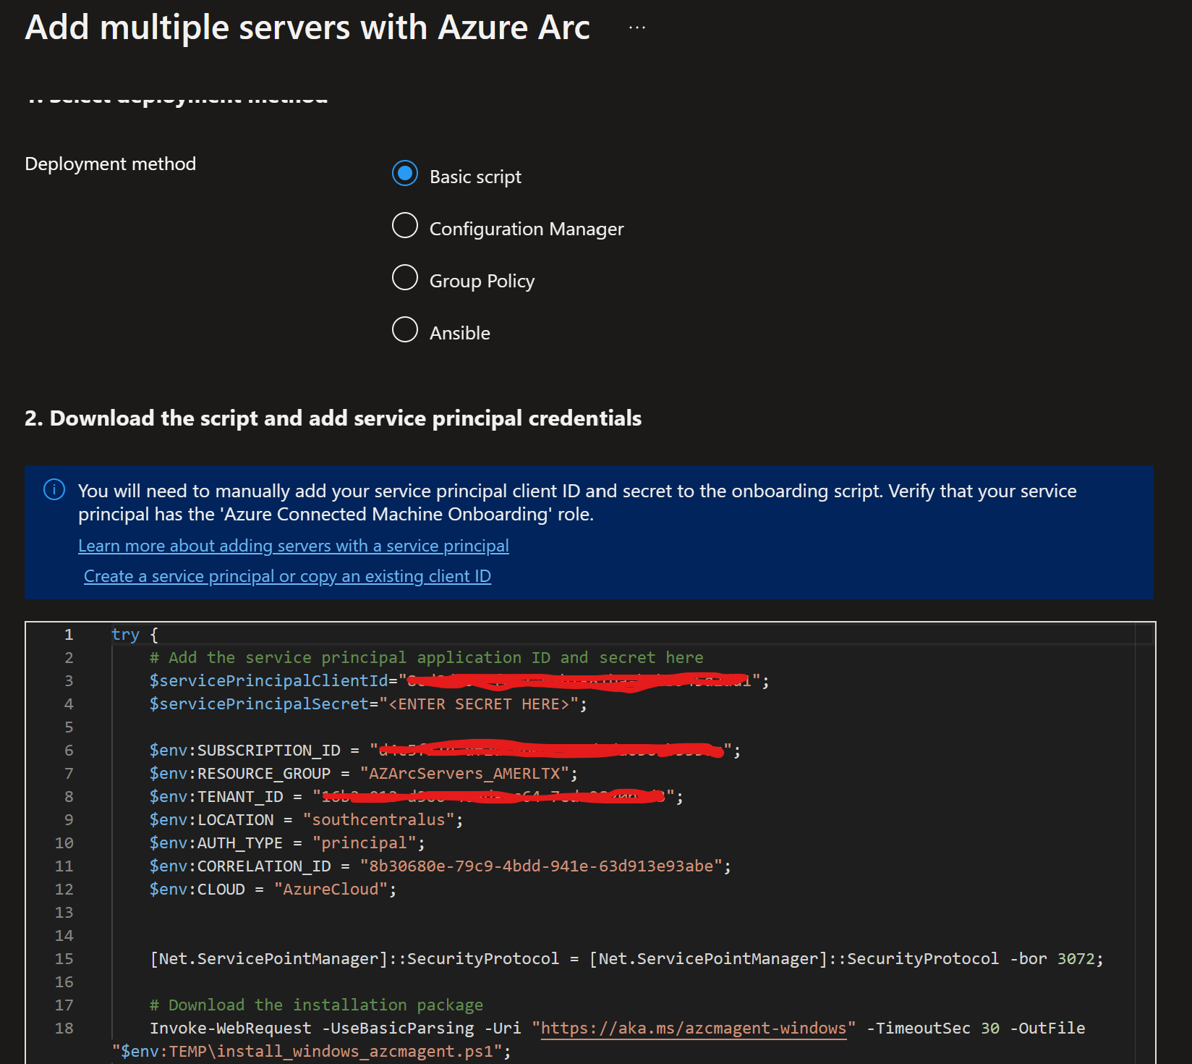

* 1. Before running the script, you will need to add the $ServicePrincipalSecret to the script which is the secret value you copied earlier when creating the service principal.

Note: The user running script on the machine must be a member of the local admins group on the windows machine, or root account for linux.

* 1. Once you have executed the script on the servers you want to onboard it will do the following:
     1. Download the agent from the Microsoft Download Center.
     2. Install the agent on the server.
     3. Create the Azure Arc-enabled server resource and associate it with the agent.
  2. Once the script is complete you should see the servers in the azure portal under azure arc, servers list.

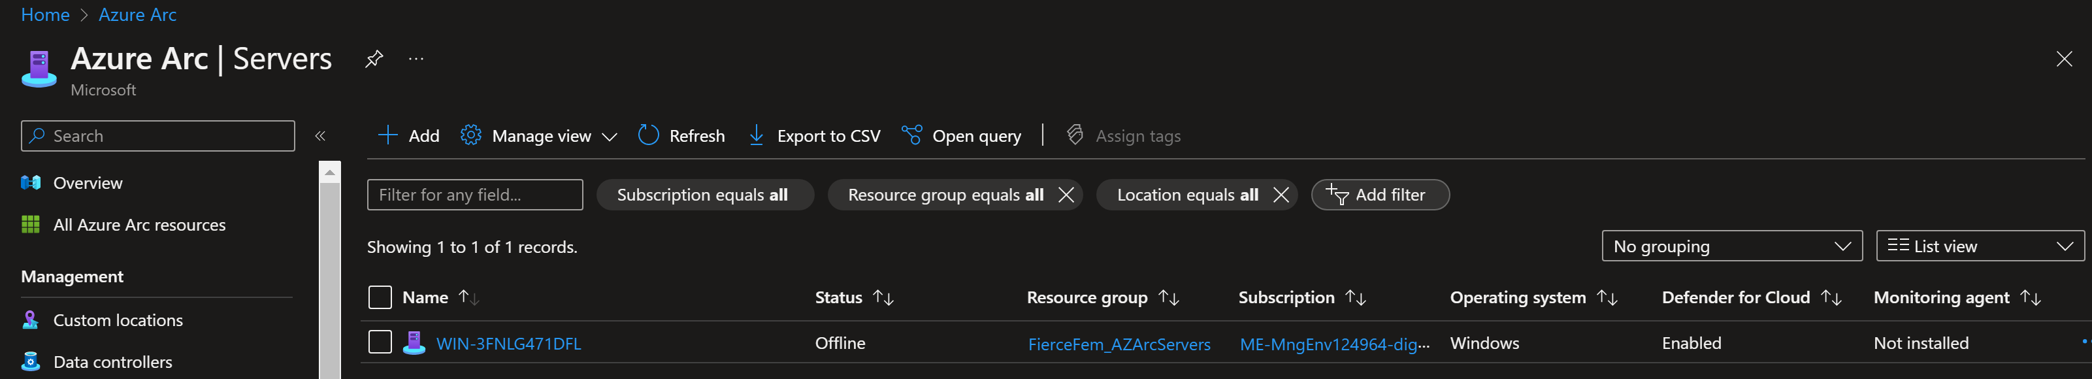

1. **Add SQL Servers to Azure Arc.** 
   1. To onboard SQL Servers from the portal select SQL Servers under Infrastructure menu. Select +add
   2. Select Connect SQL Server to Azure Arc, ensure you meet the pre-requisites. Next
   3. Choose the resource group you created for Azure Arc Resources
   4. The Azure Region where machine metadata will be stored.
   5. Select operating system
   6. You can choose to apply a different server name or leave it blank to use default host name for sql server.
   7. Set proxy server url if applicable, if not leave blank
   8. Select the license type you want to enable. Keep in mind that there could be additional costs to enable certain features. Below is a screenshot of features enabled by each license type.

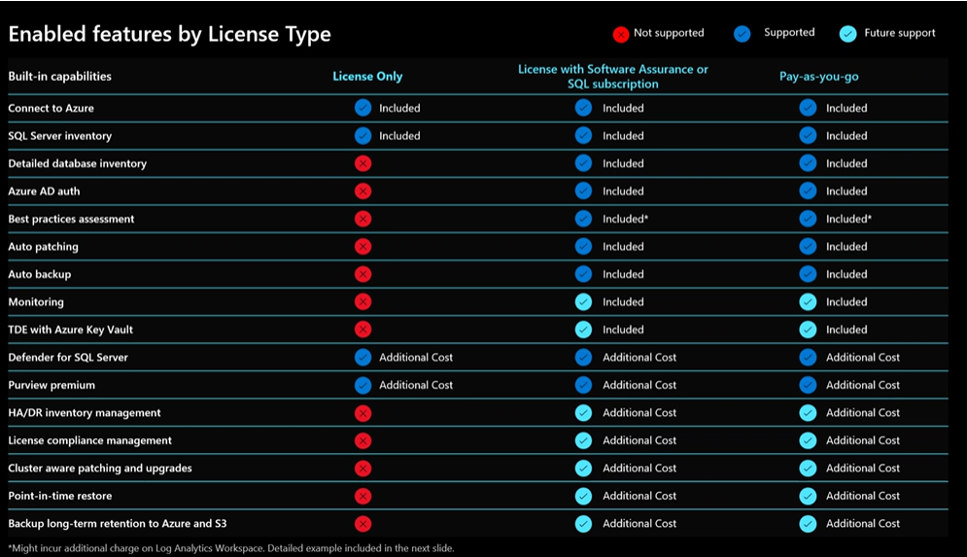

* 1. You may start with “License Only”, however, to use the SQL Best Practice Assessment you will need to use the “Paid” license type (we can go over pricing in more detail).
  2. By default, all SQL instances are registered on the servers, so you may exclude any SQL instance name you don’t want to onboard. Next

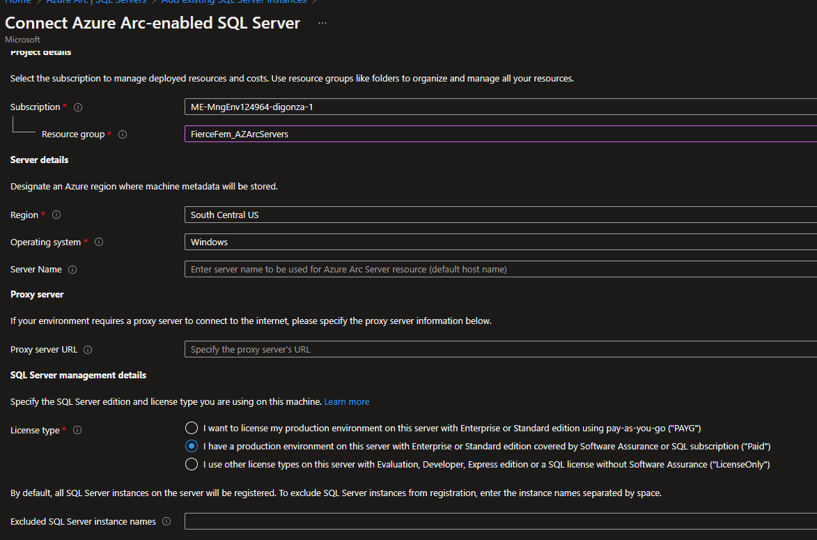

* 1. Apply any tags you’d like to add if applicable, this is optional. Next
  2. Next you will download or copy the script provided. You will need to run the script on each machine you set up beforehand (You can choose to use your organization's preferred automation tool to run at scale).
  3. Make sure the machine has network connectivity to Azure and to your target machine with SQL Server. Note (windows only): The PowerShell script you download will be unsigned. You can [sign the PowerShell script](https://go.microsoft.com/fwlink/?linkid=2222919) or you can run the script by [setting the PowerShell execution policy to allow running unsigned scripts](https://go.microsoft.com/fwlink/?linkid=2223106)
  4. To run this on multiple machines you will have to change the script and uncomment the following parameters and add the values generated earlier:

$servicePrincipalAppId="{serviceprincipalAppID}"

(from portal, app registration->select your app name ->under essentials grab the Application (client) id. Paste to script)

$servicePrincipalSecret="{serviceprincipalPassword}"

(secret value you copied and saved earlier from pre-requisites)

$servicePrincipalTenantId="{serviceprincipalTenantId}"

(from portal, app registration->select your app name ->under essentials grab the Directory (tenant) id. Paste to script)

* 1. The script:

1. Checks connectivity from your environment to Azure and specified machine

2. Onboard the host machine by deploying the Azure Connected Machine agent if not already onboarded

3. Initiates SQL Server instance discovery

4. Adds SQL Server instances on your target machine to Azure

* 1. Once the script completes you should see your instances of sql

